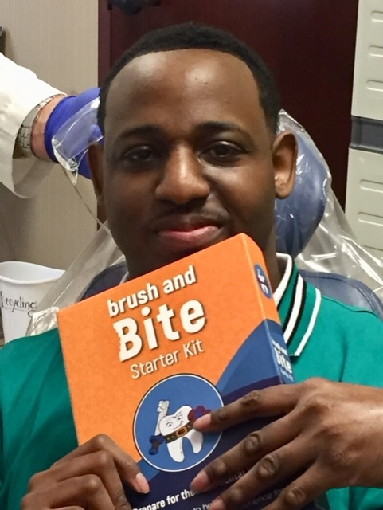  Your Are Cordially Invited  Healthy Smiles  Program  At Home Dental Care Program  To get started right away, just tap any placeholder text (such as this) and start typing to replace it with your own. Want to insert a picture from your files or add a shape, text box, or table? You got it! On the Insert tab of the ribbon, just click the option you need. | Healthy Smiles Program  ────  Learn Directly From the Experts  ────  Easy to Follow Home Care Instructions  ────  Get Your Questions Answered  ────  Click Here to Enroll NOW  United Cerebral Palsy Foundation  2200 Veterans Blvd. #103  Kenner, LA 70062  504-461-4266  www.ucphealthysmiles.org  New content weekly

